Full Name Zilin Yuan
Due Date 02/16/2026 10:20 am
EAP II
DeSorbo
Assignment Name [HW] Submit your Narrative Writing Project Final Draft
The Compass of Memory
In my native language, Chinese, we often express the concept of nostalgia as Huaijiu(怀旧). The character Huai means to cherish or harbor in one’s mind, and Jiu simply refers to the past or old times. To me, this word suggests that we are not just remembering the past. We are actively holding it close to our hearts. Based on this cultural perspective, my self-created definition of nostalgia is that it is an emotional anchor. It is a collection of warm, curated memories that stabilizes us when the present feels uncertain. As a first-year international student at Rutgers, I often feel like a small boat drifting in an unfamiliar ocean. However, my past serves as a compass. By reflecting on memories of family, friendship, and resilience, I find the direction I need to navigate my future education, relationships, and challenges.
The needle of my compass first points to my foundation, which is my family. I clearly remember one specific Chinese New Year’s Eve dinner back home. It was a freezing winter evening in my hometown, Wuhan. Outside, the wind was cold, but inside, the atmosphere was completely different. The room was bathed in warm, golden lighting. The round table was overflowing with traditional dishes that smelled of delicious sauce. I can still hear the loud, joyful chatter of my relatives catching up. This sound mixed with the background noise of the Spring Festival Gala on TV and the popping of distant firecrackers outside. At that moment, I feel a deep sense of love and belonging. Now, when I face the struggle of loneliness in the U.S., looking at this memory makes me feel safe, loved, and supported. John DiPrete notes in his article The Benefits of Nostalgia that "personal memories from long ago of family and friends can link us together in shared comforts of tradition". This idea resonates with me deeply. This memory represents my roots. It reminds me that no matter how far I travel for my education, I have a strong support system back home. It symbolizes family love that doesn't require me to achieve to be worthy. This shapes me into someone who values family. As I navigate life as an international student, I want to maintain these connections despite the distance. It also motivates me to work hard; I want to become someone capable of taking care of my family in the future, just as they have taken care of me. Above all, it keeps me humble and grateful.
Moving beyond family, my compass also guides me toward the type of connections I want to build in the future. I recall a trip to the Presidential Palace in Nanjing during the sweltering summer after our high school graduation. I was with my best friends—a group of funny, outgoing people I have known since middle school, for over six years. We had just finished our exhausting college entrance exams and were desperate for freedom. The historic architecture was solemn, but our poses were casual, and that became a vivid contrast. I can still feel the physical exhaustion in my legs from walking all day. Yet this feeling blended with the electric excitement of exploration. Our inside jokes echoed down unfamiliar streets and created a bubble of joy. In this memory, I feel freedom and independence. I feel connected to the wider world beyond my hometown. This trip wasn't just about sightseeing; it was about bonding and shared experiences. As FioRito and Routledge state, "nostalgia increases the importance people assign to relationship goals". This validates my own feelings. It represents the joy of discovering new things with people who understand me, like my friends. This encourages me to be adventurous. I am becoming someone who values experiences over material things. It reminds me that in future work or life, I should get strong relationships, friends, and teams, because the journey is always better when shared with someone who understands you.
And my compass helps me navigate through storms. My high school in Hubei Province was a "key high school," known for its intense academic rigor. For three years, my life was a bitter cycle of burying myself in piles of test papers to prepare for the Gaokao. High school was an incredibly stressful time for every Chinese student who was preparing for the Chinese college entrance examination. It was filled with academic pressure and anxiety. I lived in a classroom filled with piles of test papers. The academic pressure and anxiety felt heavy in the air. But I distinctly remember a moment after a summer storm when a rainbow appeared over the campus. The air smelled fresh and earthy because the rain had broken the heat of the day. Students rushed to the windows and hallways. They were shouting in excitement and pointing at the bright, perfect arc cutting through the dark clouds. That sight changed my mood instantly. I feel optimistic and hopeful. It brings back a sense of relief, the calm after a storm. High school was stressful at times, but this moment reminds me that beauty often follows struggle. It is a symbol that difficulties are temporary and that there is always something to look forward to. DiPrete highlights this power of memory by noting that "the regular practice of this discipline has been found to be correlated with increased resilience". This experience fosters resilience in my character. In my future career and studies, when I face failure or intense pressure, I will remember to look for the rainbows in my life or in my nostalgia. It shapes me into a person who maintains a positive outlook even in challenging environments, understanding that storms are just a passing part of the process.
Nostalgia is far more than a sentimental longing for what is gone. It is a vital tool for constructing what is to come. By remembering the memories of my family’s love, the joy of shared adventures, and the beauty of resilience, I am able to make a plan for my future. These memories do not trap me in the past; instead, they provide the gratitude, connection, and hope I need to move forward. As I continue my journey as a university student, I will keep checking this compass. I want to ensure that no matter how far I travel, I never lose my way.

Nostalgia Time Capsule
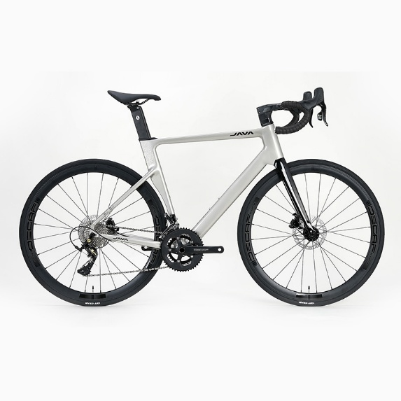

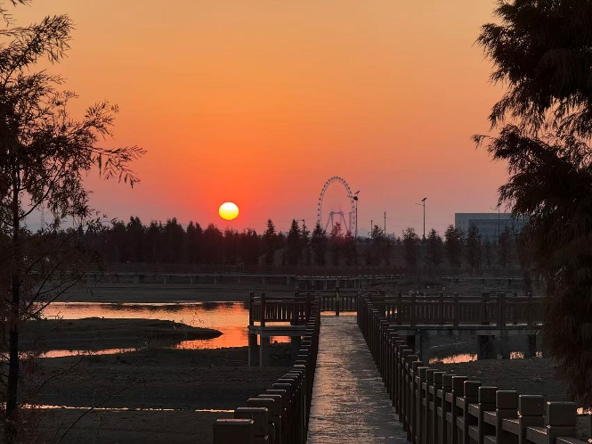

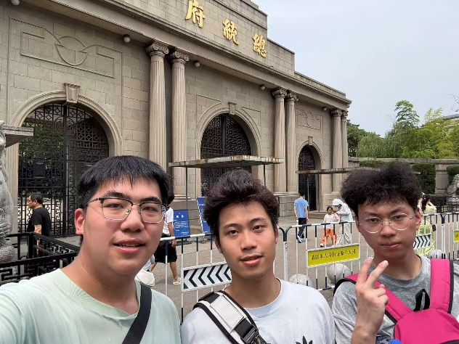
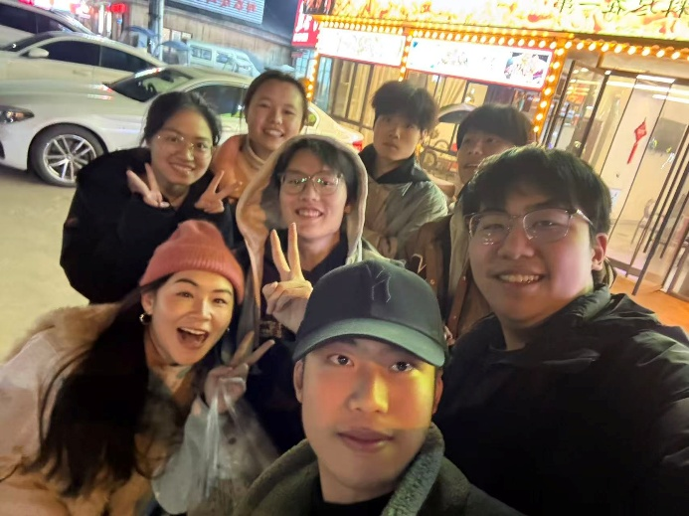
My hometown Wuhan
Riding a bicycle to school
Traveling with friends (Nanjing, China)
Having Chinese New Year's Eve dinner with my family
Fondness for my high school friends
Nostalgia for my favorite amusement park from childhood.
The rainbow in high school (makes me optimistic)
